Module 3 Lesson #4: The Sine Function
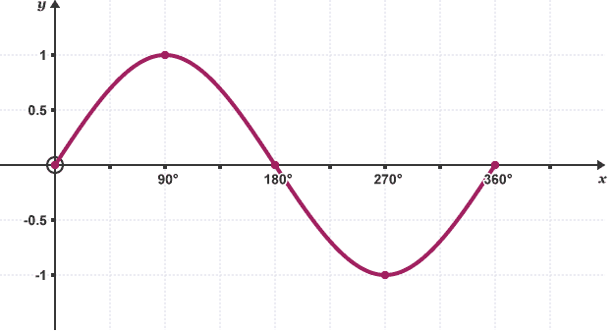

Learning Targets:
- I can graph one cycle of a sine curve.
- I can determine the period of a sine curve and can explain what it means.
- I can determine the amplitude of a sine curve and can explain what it means.
- I can determine the midline of a sine curve.
- I can apply my knowledge of sine curves to real life situations.

The Sine Function

$$θ$$ | 0º | 90º | 180º | 270º | 360º
$$sinθ$$

You just graphed one cycle of $y=sinx$
$$y=asinbx+d$$

$amplitude=$

frequency =

$$period =$$

$$midline=$$

Example 1: Graph one cycle of $y=2sinx$

Example 2: Graph one cycle of $y=-sinx$

Based on the graph, what is the value of $y=-sinx$ when $x=\frac{3π}{2}$.

Example 3: Graph one cycle of $y=2sin2θ$

What is the maximum height of $y=2sin2θ$? What is the value of $θ$ at the maximum height?

If you were to graph $y=2sin2θ$ from $[0,2π]$, how many cycles would you see?
Example 4: Graph one cycle of $f(x)=-3sin3θ$

State the range of $f(x).$

Graph one cycle of $f\left(x\right)=-3sin3θ+2$. What transformation is taking place?

Example 5: Graph one cycle of $y=5sin\frac{x}{2}-3$

Example 6: Graph one cycle of $y=3sin\frac{π}{2}θ$

Writing the Equations of Sine Functions

Example 1: Sketch one cycle of a sine curve with an amplitude of $\frac{1}{3}$ and a period of $π$. Write the equation of this curve.

Example 2: Find the period for each of the sine curves below. The write an equation for each function. Each graph goes from $[0, 2π]$

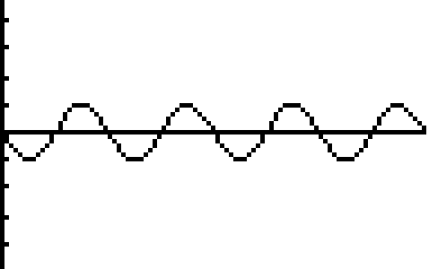
Function A Function B
